Program Review – Global Communities
Jones Symbaloo.com Links
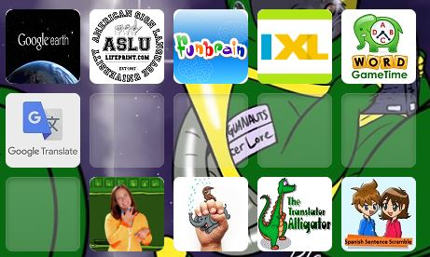
Google Earth: https://www.google.com/earth/
Google Translate: https://translate.google.com/
American Sign Language University: http://www.lifeprint.com/
Signing Time Kids: http://www.signingtimekids.org/game6.html
Funbrain Sign Language Alphabet: https://www.funbrain.com/signs/index.html
Funbrain The Translator Alligator: https://www.funbrain.com/lang/index.html
SmartyGames Spanish Sentence Scramble: http://www.smartygames.com/igre/readingGames/sentenceScrambleSp.html
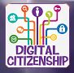
Digital Citizenship: http://www.digitalcitizenship.net/

